**A**

**Project Report**

**on**

**"8x8x8 LED Cube using Arduino"**

**Prepared by**

Jayshil Patel (18EC068)

**Under the guidance of**

Prof. Vishal Tank

**Submitted to**

Charotar University of Science & Technology for Partial Fulfillment of the Requirements for the Degree of Bachelor of Technology

in Electronics & Communication

EC 249 – Mini Project-I

of 4th Semester of B.Tech

**Submitted at**



**DEPARTMENT OF ELECTRONICS & COMMUNICATION**

**Faculty of Technology & Engineering, CHARUSAT**

**Chandubhai S. Patel Institute of Technology**

**At: Changa, Dist: Anand – 388421**

**Mar 2020**



**CERTIFICATE**

This is to certify that the report entitled “**8x8x8 LED CUBE**” is a bonafide work carried out by Anuj Bhatt under the guidance and supervision of **Prof. Vishal Tank** for the subject **Mini Project-II (EC249)** of 4th Semester of Bachelor of Technology in Electronics & Communication at Faculty of Technology & Engineering (C.S.P.I.T.) – CHARUSAT, Gujarat.

To the best of my knowledge and belief, this work embodies the work of candidate himself, has duly been completed, and fulfills the requirement of the ordinance relating to the Subject specified for 3rd semester of the University and is up to the standard in respect of content, presentation and language for being referred to the examiner.

Under the supervision of,

Prof. Vishal Tank

Assistant Professor

Department of Electronics & Communication,

C.S.P.I.T., CHARUSAT-Changa.

Dr. Trushit K. Upadhyaya

Head of Department,

Department of Electronics & Communication

C.S.P.I.T., CHARUSAT- Changa, Gujarat.

**Chandubhai S Patel Institute of Technology (C.S.P.I.T.)**

**Faculty of Technology & Engineering, CHARUSAT**

At: Changa, Ta. Petlad, Dist. Anand, Gujarat - 388421

**ABSTRACT:**

A normally working LED can be modified to a great looking attractive cube of 512 leds using a common anode and common cathode connections we can decrease the number of input pins , hence the i\o pins can be multiplexed , the sole purpose of this cube is to display a object in 3D, it's just better hologram, we can display any object on the cube using a simple program, it can also be used a decoration and display.

**Acknowledgement:**

I take this opportunity to express my profound gratitude and deep regards to my guide Prof. Vishal Tank and coordinator of E&C department of CSPIT, Prof. Trushit Upadhyaya, for their exemplary guidance, monitoring and constant encouragement throughout the course of this project. The blessing, help and guidance given by them time to time shall carry me a long way in the journey of life on which I am about to embark.

I also take this opportunity to express a deep sense of gratitude my parents for their cordial support, valuable support and guidance, which helped me in completing this task through various stages.

Jayshil Patel (18EC068)

CSPIT, CHARUSAT

**TABLE OF CONTENT**

Abstract………………………………………………………………………………….….4

Acknowledgement……………………………………………………………………….....…...4

**Chapter 1: Introduction of Project...……..…………………………………………..…..7**

1.1 Problem…..………….…………………………………………………………..….7

1.2 Solution………...………………………………………………………………..….7

**Chapter 2: Project Description (Hardware)...…………………………………………...7**

2.1 Block Diagram…………………………………………………...…………………7

2.2 Circuit Diagram………………………………………………………………….….9

**Chapter 3: Components and Its Details…………... ……………………………………10**

3.1 List of Components………………..…………………………………….……..….10

3.2 Details of components……………… ………………………………….………....10

**Chapter 4: Implementation………………………... …………………………..……….12**

4.1 Hardware Implementation…..……..……………………………………...……….12

4.2 Software Implementation ……….…………………………….…………..…..…...13

C**hapter 5: Applications and Future scope.......…... …………………………………….15**

5.1 Applications…………….…..……..…………………………………….……..….16

5.2 Future Scope.……………. ……………… …………………………….………...15

**Conclusion………………………………………………….……………………..………16**

**Reference………………………..………………………………………………………..17**

**CHAPTER 1: INTRODUCTION OF PROJECT**

LED cube is stacking up of LED , patterns objects and coordinates can be displayed of the cube

The goal of this design is to be able to output and modify the LED array fast enough to see a persistent image: The first issue that must be dealt with is the physical construction of the array. The array will be 8x8x8 LEDs, accounting for a total of 512 devices. Due to lack of accessibility we will have to make certain that each LED is functional and stays so throughout the construction. A sturdy base and casing will also have to be provided for the array, as the construction doesn’t allow for a large amount of structural integrity. A wooden base and a Plexiglas case is proposed to deal with this issue and to protect the LED array from general jostling and movement. Due to the very large number of LEDs that need to be used at once, current considerations will have to be taken into account, verifying that we have enough power to supply a good level of luminescence so that we may not only turn on all LEDs but also modify them through pulse width modulation.

**1.1 PROBLEM:**

Sometimes its harder to view a object in 2d drawings, it’s hard to imagine a drawn picture rather than viewing itself in 3d.

**1.2 SOLUTION:**

When constructing the actual LED array we have chosen to construct the array in layers, verifying that all LEDs function after every step. Due to close proximity soldering there is a high chance that some of them may burn out and we would like to catch this early on. Once we have all layers completed we will stack them and solder the layers on by one till they are fully assembled. We shall also place several strong strands of wire to support the structure and increase its integrity.

**CHAPTER 2: Project description**

**2.1 Block Diagram**

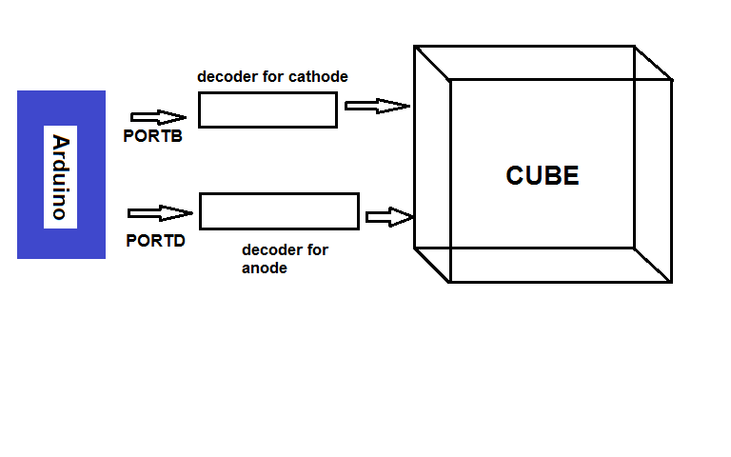

Figure1(block diagram)

The stored code from arduino will flow out through PORTB and PORTD to their respective decoders , the decoders will further decode the data, increasing the output lines, hence the multiplexed data will flow through their respective anode and cathodes

The cube have 512 led, hence it is impossible to have a microprocessor with 512 output ports hence we must decrease the input ports of the cube

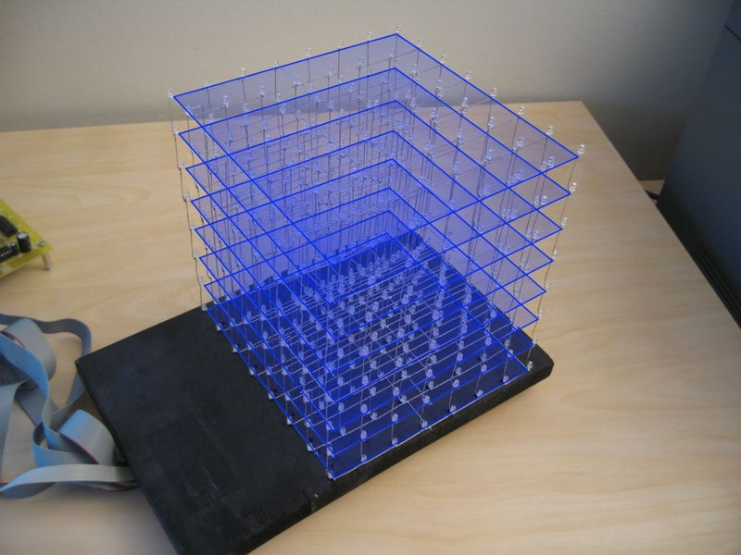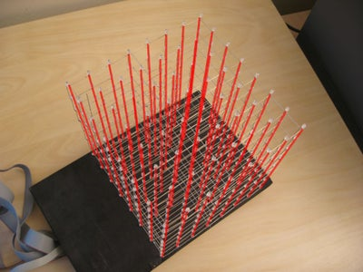

Figure2(common cathode) Figure3(common anode)

Hereby reducing 512 output ports we can now have 72 input lines to individually address each led

**2.2 Circuit Diagram**

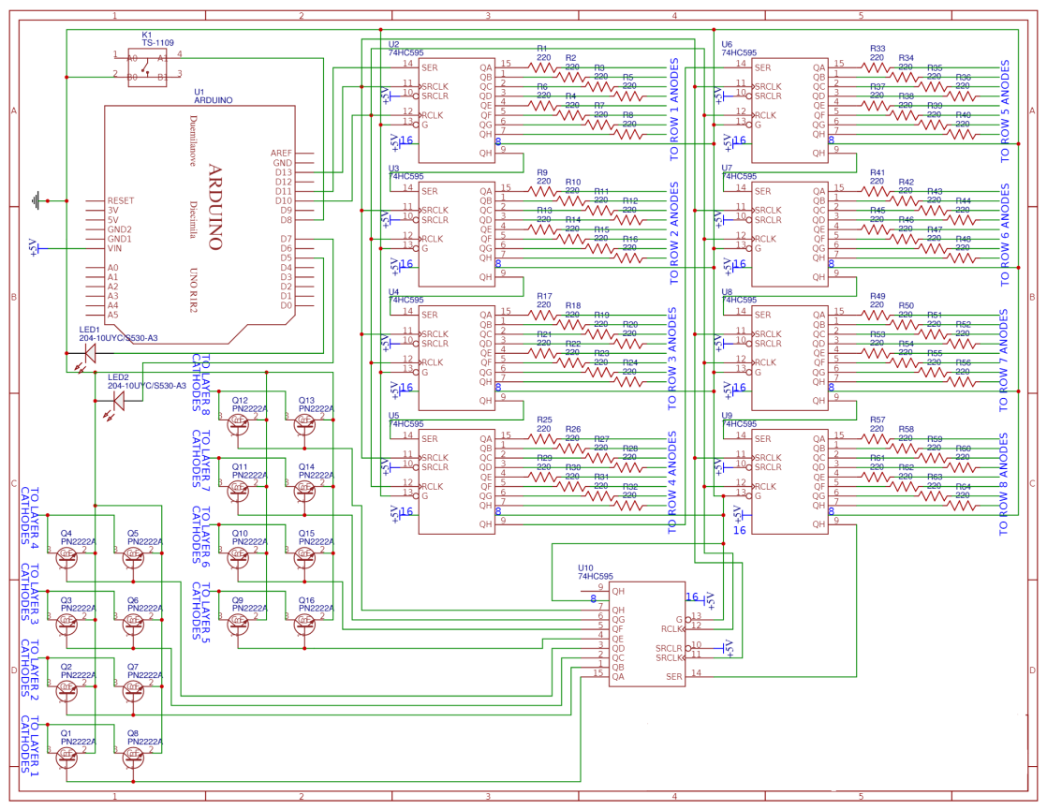

Figure4(circuit schematic)

Figure 4 shows how the circuit will look . number of IC is depended upon number of ports of anodes and cathodes.

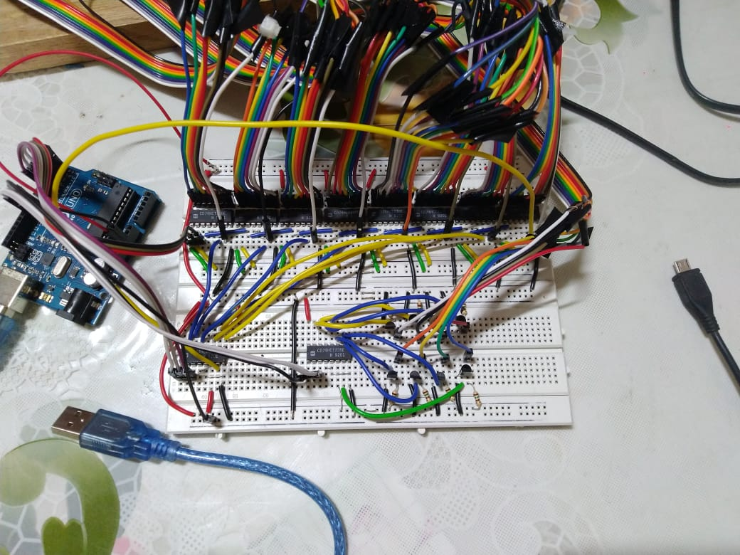

Figure5(circuit complete)

Figure 5 shows the picture of circuit upon completion, the circuit includes transistors array cascaded IC and resistors to decrease voltage.

**Chapter 3: Components and Its Details**

**3.1 list of components**

* 74238 -3 to 8 line decoder
* Pn2222-general transistor
* TLHB5400 5mm transparent led

**3.2 description of components**

**74238** ic:- this is general 3 to 8 line decoder we will be using this decoder in cascaded form

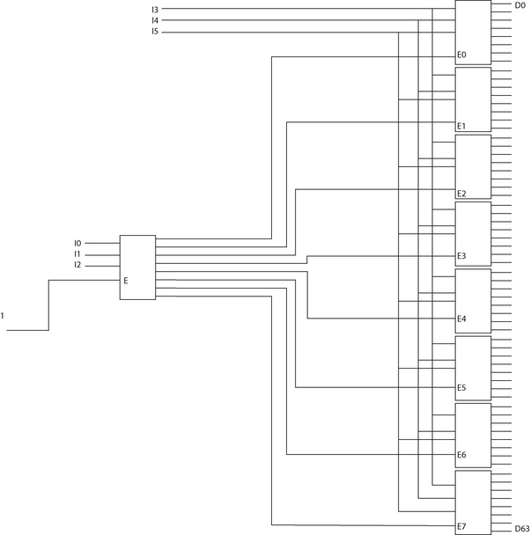 figure 6(cascading 74238)

Figure 6 shows how 6 bit binary output can be converter to 63 decimal value numbers, using this concept and multiplexing the outputs we can get all anodes address

**PN2222 :-**this transistor will help making a not gate at end of cathode dedicated 74238 ic, to activate a cathode layer we must make the cathode layer to ground, so we must have an active low signal at 74238, so we will be using not gate made by transistors

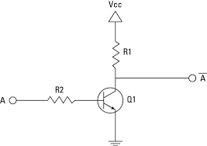

Figure 7(not gate using transistors)

Figure 7 show how we can make a not gate using transistor

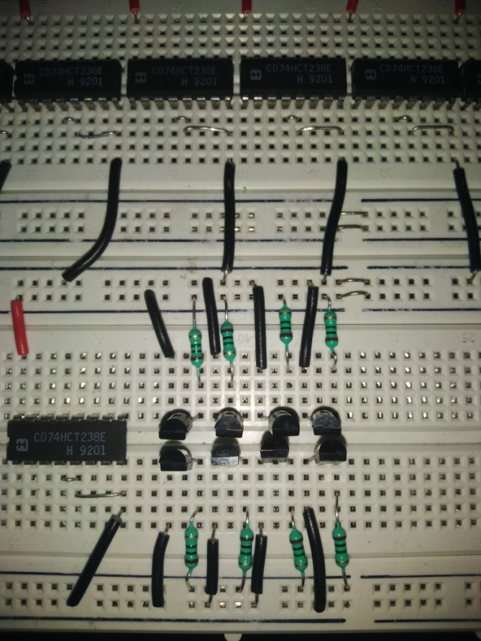

Figure 8(transistor array)

Figure 8 shows how transistor for each cathode layer is implemented in array

**Chapter 4: Implementation**

**4.1 Hardware Implementation**

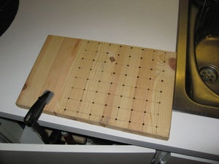

**Figure9(drilled wooden board)**

Figure 9 shows the drilled board with 64 holes distributed in 8 rows and 8 columns equidistant from each other

Onto this board we must insert our led then start soldering such that each layer comes in great common cathode layer and attached altogether as shown in figure 10

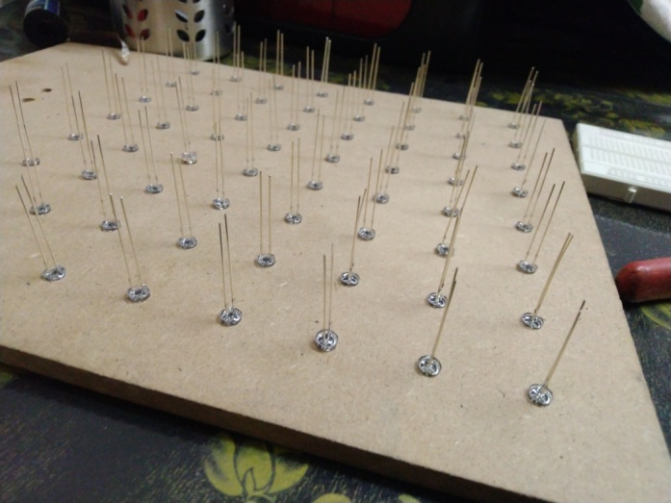

Figure10(inserted led in board)

After completing layer we must insert each layer over another with anodes soldered as shown in figure 11

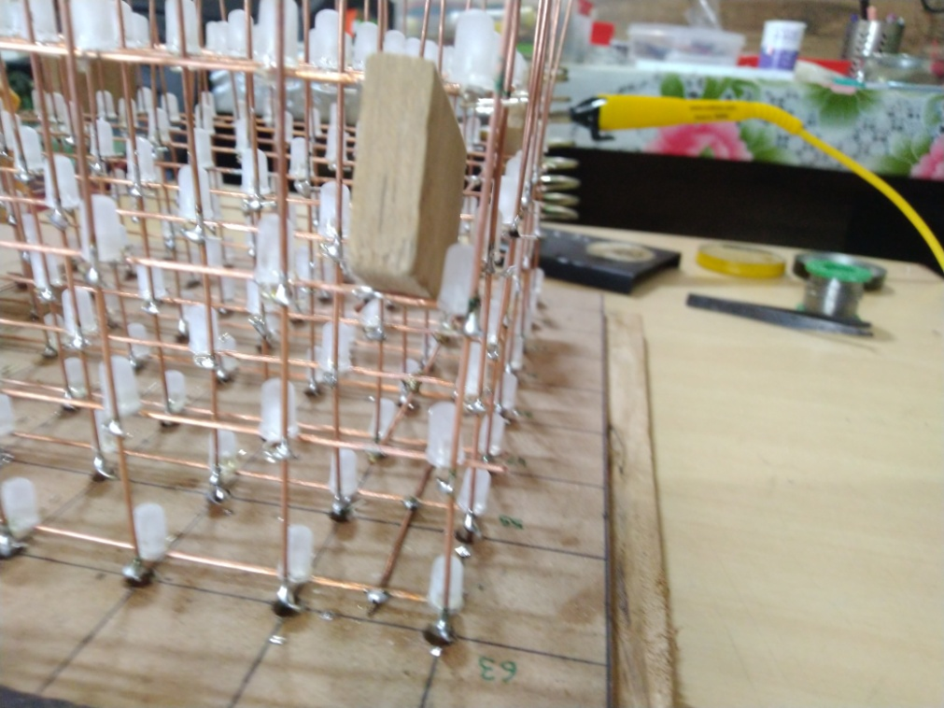

Figure11(anode soldering)

Using Ribbon cable greatly reduces complexity and confusion of multiple wires

As shown in figure 12 and 13

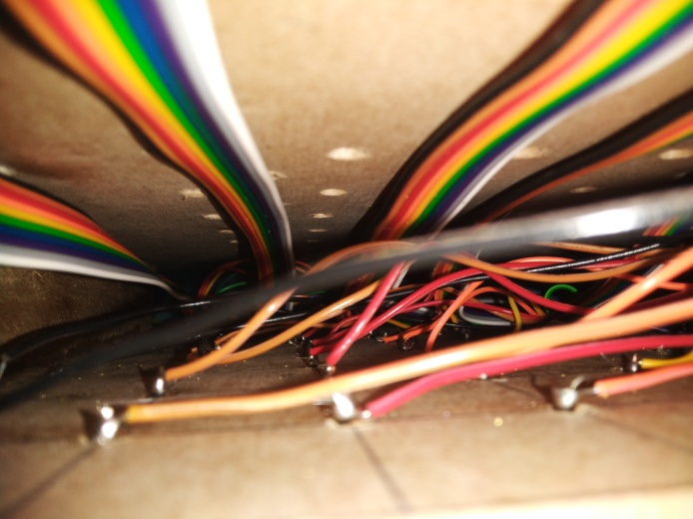

Figure12(lower base of anodes under the wood)

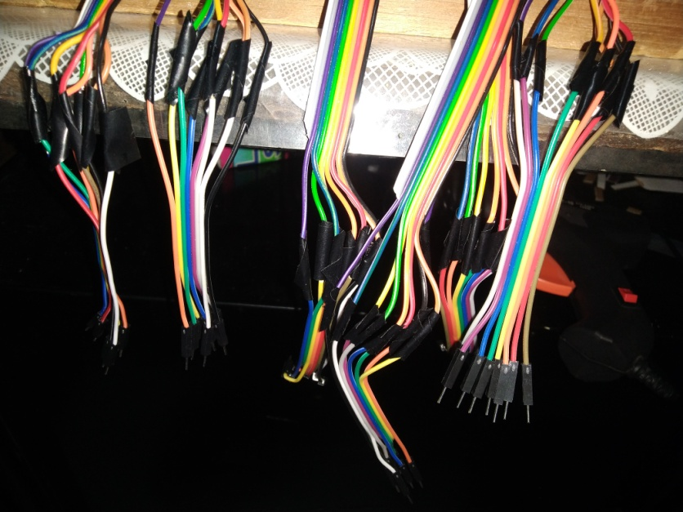

Figure13(side view of anode ports)

**4.2 Software implementation**

simple multiplexing based arduino codes can be written like shown in figure 14

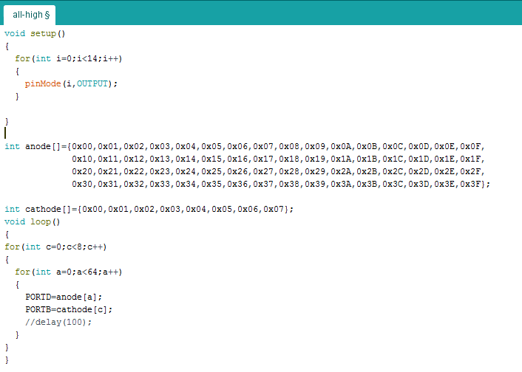

Figure14(normal all hiigh code)

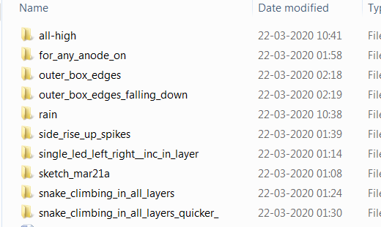

Figure15(different animations)

Figure 15 shows how different animations can be uploaded and written on arduino

**Chapter 5: Applications and Future scope**

**5.1 Applications**

With changes in led like using neopixel or RGB led we can change the colors have fading and rising effects in patterns we can add animations of fireworks interface the cube with HC-05 Bluetooth module to change pattern from Bluetooth, or we can interface it with wifi module to change the colors and pattern through wifi

Led cube can be made into use in architecture field to demonstrate the view of objects buildings in 3d, in mechanical field to view the components in large and on 3d view, because sometimes it is harder to represent a object on 2d rather than 3d, presenting an object in 3d leaves a better and good impression than 2d.

**5.2 Future scope**

The same conceptual process for controlling the LED’s in the 16x16x16 cube design is utilized in our project. The cube uses multiplexing to generate a 3D image by displaying 2D panels in rapid succession - too quickly for the eye to notice. Pulse Width Modulation is used to control the color of each diode. This is done by varying the duty cycle of each individual red, green, and blue diode. A higher duty cycle (diode is on longer than it is off) corresponds to a brighter LED of that specific color. By varying the duty cycles, and correspondingly the brightness of each LED color, the microcontroller is able to display any color from the LED.

With changes in led like using neopixel or RGB led we can change the colors have fading and rising effects in patterns we can add animations of fireworks interface the cube with HC-05 Bluetooth module to change pattern from Bluetooth, or we can interface it with wifi module to change the colors and pattern through wifi

**Conclusion**

The completion of this project documentation culminated in a clear and precise direction moving toward the completion of a final prototype of the 3D LED cube. Throughout the research phase of development, I had built a high level of proficiency in my areas of concentration, while maintaining competency across all the areas of the project design. The design phase was where the individual skills of the mine were put to the test - creating a highly detailed and formulated design plan to achieve the required specifications for the completed prototype. Each stage of this design process was heavily documented and outlined in this paper, adding accountability to each major decision made - as each step had to have specifications and facts supporting that particular directive.

**Reference**

* [www.alldatasheets.com](http://www.alldatasheets.com)

for providing datasheets of all components

* [www.github.com](http://www.github.com)

for schematic and design flow of project

* [www.instructables.com](http://www.instructables.com)

for soldering scheme and board drilling

* [www.alltransyouknow.com](http://www.alltransyouknow.com)

for transistor knowledge and not gate prototyping